File Handling 101

Create your structure

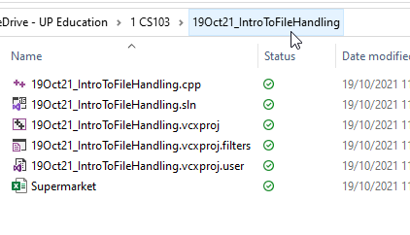

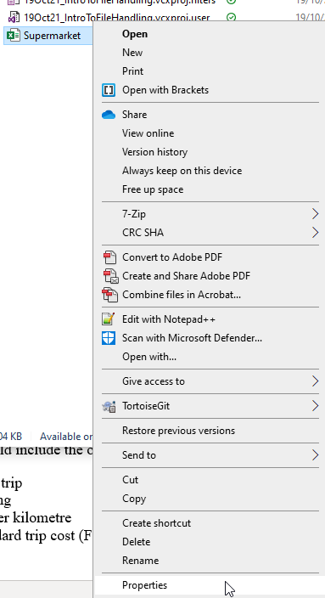

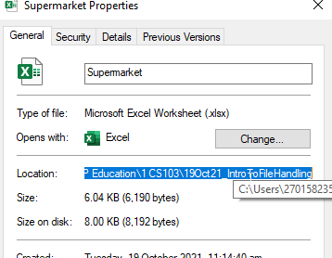



Make sure you put the file name in “ <quotes>” and add the /filename.csv at the end of the path

[Remember to change the backslashes to forward slashes!] So:

